**Summary**

This laboratory experiment is the gas engine test which can be related to the concept and theory of thermofluids. Some values from the Boys’ Calorimeter and the Gas Engine (National) is recorded to determine the calorific value of natural gas and the SFEE of the Boys’ Calorimeter and the fuel conversion efficiency of the Gas Engine. In addition, the engine performance parameters including: Equivalence Ratio, Specific Fuel Consumption, Indicated Mean Effective Pressure, Mechanical Efficiency and Power Density are compared with a modern petrol engine and listing the reason for the differences. Despite, the relative size of the terms in the ‘energy balance’ will be discussed by considering the components that are ‘unaccounted for’.

**Engine performance parameters:**

1. **Equivalence ratio**

As compared with the modern petrol engine, which the equivalence ratio is 1, the value that is calculated from the lab experiment is 1.075. The slightly higher value than the optimised value (1.0) can be explained as the incomplete combustion of the fuel in the combustion chamber, which affects the fuel consumption and gas engine efficiency. There is enough fuel to ignite the mixture to do work. However, the fuel ejected to the chamber is in excess, causing the incomplete combustion in the chamber. The fuel which is not combust and transfer into work will still be released out of the chamber with the exhaust gas together. This will decrease the efficiency of the engine, as some fuel is wasted. This might be caused by the faulty of control system in the engine which adjust the amount of fuel into the chamber or the small amount of leakage fuel between the engine stroke process.

1. **Specific Fuel Consumption (sfc)**

The value of sfc which is calculated is 0.317 kg/kWh, which is almost 27% higher than the minimum sfc of current petrol engine (0.25 kg/kWh). With the same Calorific Value for both petrol and natural gas, the gas engine requires higher mass of fuel to produce one unit of power. This can be explained as the size and weight of the modern petrol engine is smaller than the gas engine in the laboratory. The massive gas engine will have higher inertia and bigger drag effect as compared to the modern petrol engines, and therefore more fuel is needed to produce 1 unit of useful output power.

1. **Indicated Mean Effective Pressure (IMEP)**

The IMEP of the gas engine has a value of 790 kPa, which is 12% less than the maximum IMEP of current petrol engines (900 kPa). The slight difference in the value can be explained by the difference in material strength of the engine cylinder. The IMEP value of the gas engine is acceptable as long as the useful power produced is efficient enough for the requirement. The difference in material strength of the engine cylinder in the stroke, especially in terms of yield stress, will decide the maximum pressure that the cylinder can withstand before exploding or break, assuming that both gas engines and petrol engines do not undergo plastic deformation. As we know, petrol is denser than gas fuel, therefore the design of petrol engine will be considered with stronger material and therefore having higher IMEP value as compared to the IMEP value of gas engines. In addition, turbocharged engine which is more likely to be found in petrol engine, has real ly high IMEP value, which we can say that petrol engine is expected to produce higher force than gas engine, therefore having stronger material in the engine cylinder.

1. **Mechanical Efficiency**

The gas engine has a mechanical efficiency of 66.5% however the maximum value for engine is about 90%. This means that there might be more power lost in every process of the engine to produce sufficient output, including the mechanism of engine and the power transmission system. Power is lost through friction, wear and tear of compartments and producing unnecessary heat and even sound in every part of the engine. Comparing a typical petrol engine and the gas engine in the laboratory, the transmission system of the gas engine can be said to be more complex. The massive size of the engine shows that the transmission between the input to the output would be a longer way as compared to petrol engine. In between, energy will be lost to surrounding causing the efficiency to be lowered as compared to a modern engine.

1. **Power Density**

The power density of gas engine is 0.842 kW/litre, which is significantly less then the maximum value of a modern petrol engine for automobiles, which is about 40 kW/litre. From the information provided by the lab demonstrator, the gas engine tested is a 1900s model, which can be said to be an outdated version engine as compared with the modern ones. This might cause the outdated concept in design to produce lower energy or power per unit of fuel. Same as the explanation in the previous points, since the calculation of power density is based on the useful power output, the power lost in between the conversion system including the combustion and transmission may cause the power density to significantly if the ratio of power lost is high. Furthermore, with the improvement of technology, the modern petrol engine can produce higher force or torque from the engine, which related to the efficiency of the engine, would have higher power density as compared to the gas engine tested.

**Relative size of “Energy Balance” and unaccounted energy loss**

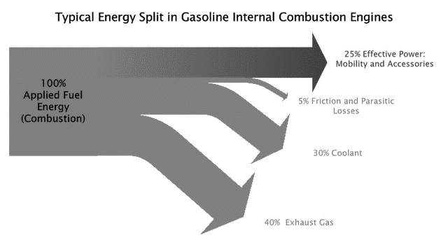

By comparing our estimated energy split from the gas engine experiment in the laboratory with the typical energy split in the gasoline internal combustion engines, the useful power output (21.83 %) is just slightly less than the typical ones. The power to the engine coolant is almost similar (30.895 %). However, there is a big difference in the power which goes to the exhaust. From the percentage estimated, which is around 20% and the theoretical value 40%, the value is doubled. This explains why the big portion of unaccounted energy loss do exist. This might due to the exhaust gas temperature gauge is placed further away from the exhaust outlet, which some of the heat is absorbed by the material around the exhaust gas. In addition, the exhaust which is not is gas form but in soot form do significantly decrease the exhaust temperature, which caused inaccuracy in the power loss to the exhaust. Furthermore, the friction and parasitic loss in the whole system is not taken into account in any part of the experiment. The massive structure of the gas engine, inclusive of big wheel to measure the brake tension, movement of the 4 strokes in the engine cylinder or any parts of the engine which has movement, will have friction which leads to a source of power loss too. Heat and sound which is produced by the rubbing between two surfaces in any part of the engine will cause energy loss too which contribute to the unaccounted power loss.

**Conclusion**

To understand the structure and working principle of gas engine, the experiment carried out would be a great opportunity to have deep understanding of engine structure. After recording the data required to calculate the equivalence ratio, specific fuel consumption, IMEP, mechanical efficiency and power density, the values are used to compare with a modern typical petrol engine to further explain the differences. From the result of the experiment and comparison with the values given for modern petrol engines, we can draw the conclusion that the improvement of technology in engine design significantly increase the mechanical efficiency and power density of the engine. Engineers are trying to further improve the efficiency by introducing hybrid engine or even full electrical engine to minimize the heat loss and increase the percentage of effective power.